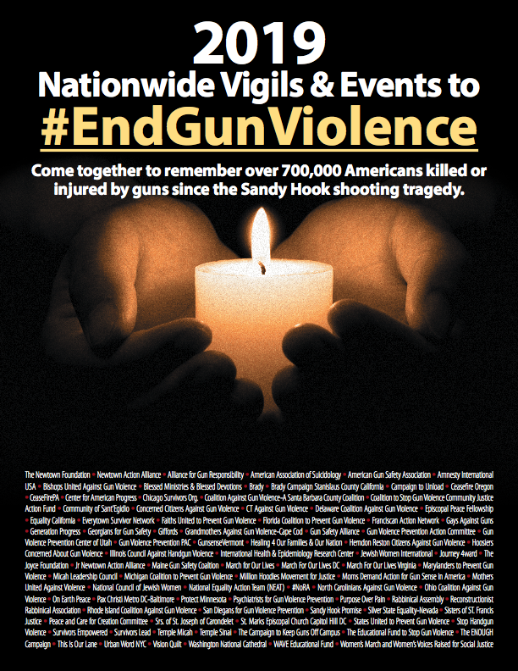

And attend a vigil or event at:

(INSERT LOCATION, ADDRESS, DATE AND TIME HERE)

At hundreds of locations nationwide, we will give voice to all ***victims***

and ***survivors*** of gun violence and together help #EndGunViolence in America.

(INSERT WEBSITE OR CONTACT INFO HERE)